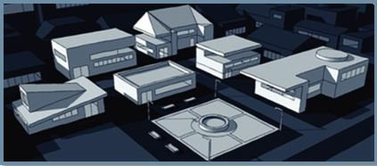

**Using PI Data with MATLAB**

**Program**

**OSIsoft**

**vCampus**

**White Paper**

*How to Contact Us*

Email: vCampus@osisoft.com

Web[: http://vCampus.osisoft.com](http://vcampus.osisoft.com/) > Contact Us

**OSIsoft, LLC.**

777 Davis St., Suite 250

San Leandro, CA 94577 USA

Houston, TX

Johnson City, TN

Mayfield Heights, OH

Phoenix, AZ

Savannah, GA

Seattle, WA

Yardley, PA

**Sales Outlets and Distributors**

* Brazil
* Middle East/North Africa
* Republic of South Africa
* Russia/Central Asia

[**WWW.OSISOFT.COM**](http://www.osisoft.com/)

**Worldwide Offices**

**OSIsoft Australia**

Perth, Australia

Auckland, New Zealand

**OSIsoft Europe**

Altenstadt, Germany

**OSI Software Asia Pte Ltd.** Singapore

**OSIsoft Canada ULC** Montreal, Quebec

Calgary, Alberta

**OSIsoft, LLC. Representative Office**

Shanghai, People’s Republic of China

**OSIsoft Japan KK**

Tokyo, Japan

**OSIsoft Mexico S. De R.L. De C.V.** Mexico City, Mexico

* South America/Caribbean
* Southeast Asia
* South Korea
* Taiwan

OSIsoft, LLC. is the owner of the following trademarks and registered trademarks: PI System, PI ProcessBook, Sequencia, Sigmafine, gRecipe, sRecipe, and RLINK. MATLAB® is a registered trademark of The MathWorks, Inc. All terms mentioned in this book that are known to be trademarks or service marks have been appropriately capitalized. Any trademark that appears in this book that is not owned by OSIsoft, LLC. is the property of its owner and use herein in no way indicates an endorsement, recommendation, or warranty of such party’s products or any affiliation with such party of any kind.

RESTRICTED RIGHTS LEGEND

Use, duplication, or disclosure by the Government is subject to restrictions as set forth in subparagraph (c)(1)(ii) of the Rights in Technical Data and Computer Software clause at DFARS 252.227-7013

Unpublished – rights reserved under the copyright laws of the United States.

*© 1998-2010 OSIsoft, LLC*

# TABLE OF CONTENTS

OVERVIEW 1

ABOUT THIS DOCUMENT 1

WHAT YOU NEED TO START 1

USING PI DATA INTO MATLAB 2

WHAT IS MATLAB? 2

WHAT DOES MATLAB HAVE TO DO WITH PI? 2

THE PI DATA TO MATLAB PROGRAM 3

STARTING THE PROGRAM 3

ADVANCED DATA SETTINGS 5

THE ASSET FRAMEWORK TAB 6

THE ELEMENT TREEVIEW 6

TRANSFERRING DATA: EXPORT AND IMPORT 7

THE EVENT FRAMES TAB 8

SEARCH FOR AN EVENT FRAME 8

EVENT FRAME TIME RANGE 8

THE PI POINTS TAB 9

SAVING YOUR WORK 9

THE TRANSACTION HISTORY 9

EDITING A TRANSACTION 10

SAVING THE TRANSACTION LOG 10

IMPORTING THE TRANSACTION LOG 10

THE MATLAB WINDOW 11

REVISION HISTORY 11

ii

# OVERVIEW

## ABOUT THIS DOCUMENT

This document is exclusive to the OSIsoft Virtual Campus (vCampus) and is available on its online Library, located a[t http://vCampus.osisoft.com/Library/library.aspx.](http://vcampus.osisoft.com/Library/library.aspx) As such, it is provided 'as is' and is **not supported** by OSIsoft's regular Technical Support.

Any question or comment related to this document should be posted in the appropriate OSIsoft vCampus discussion forum ([http://vCampus.osisoft.com/forums)](http://vcampus.osisoft.com/forums) or sent to the OSIsoft vCampus Team at vCampus@osisoft.com.

## WHAT YOU NEED TO START

You must have the following software installed to use PI data in MATLAB:

* PI Server 3.3 or higher
* MATLAB (the version we tested is R20014b, or 8.4.0.150421)

Either of the following:

* + PI OLEDB Provider o PI JDBC Driver + MATLAB's Database Toolbox o PI OPC DA/HDA Server + MATLAB's OPC Toolbox o PI OPC DA/HDA Server + Integration Objects' OPC HDA Toolbox o Microsoft Visual Studio (possibly with PI ACE) o PI System Management Tools (SMT)o PI DataLinko The PIConfig utility
  + Microsoft SQL Server with Data Transformation Services (DTS) and Integration

Services (SSIS)o PI AF Software Development Kit (PI AF SDK)*o PI Web API*

*\* Tested with MATLAB version R2014b*

# USING PI DATA INTO MATLAB

## WHAT IS MATLAB?

MATLAB is a language for technical computing that integrates computation, visualization, and programming. It is provided with a graphical environment where one can express problems and get solutions in familiar mathematical notation. Typical uses include:

* Math and computation
* Algorithm development
* Modeling, simulation, and prototyping
* Data analysis, exploration, and visualization
* Scientific and engineering graphics
* Application development, including graphical user interface building

MATLAB is an interactive system whose basic data element is an array that does not require dimensioning, and allows quickly solving many technical computing problems such as those with matrixes and vectors.

MATLAB features a family of add-on application-specific solutions called toolboxes, some of which we will use in this paper as they allow getting values outside of MATLAB, using standard protocols.

## WHAT DOES MATLAB HAVE TO DO WITH PI?

The PI Server and MATLAB are in several ways complementary. For instance, PI is meant to effectively collect and store masses of time series data in real time, whereas MATLAB is in no way a data store. MATLAB and its convenient ad-hoc computing interface extend the computing ability of PI by adding its library of advanced functions such as Fourier transforms, resolution of differential equations, neural networks, Markov chains, etc.

In other words, combining the "real-time data historian" capabilities of PI and the advanced mathematical and computing functions of MATLAB seems like a logical choice in areas like R&D and labs. Another notable advantage of connecting PI to MATLAB is the possibility of continuous MATLAB computations rather than working with a static data sample.

In order to cite some real-world applications of connecting MATLAB to PI, we have prepared some numerical results in the "Simulation" section. We model a PI-based production organization and use the MATLAB optimization toolbox to calculate the optimal production level in real time.

Now we just need to bring that PI data into MATLAB (and most likely push the results of the analyses back to PI).

# 

# THE PI DATA TO MATLAB PROGRAM

## STARTING THE PROGRAM

The program automatically connects to or launches a COM-Enabled Matlab. If there is a default AF Server, that is connected to and the first database’s Elements and the Server’s PI Points are loaded in.

**Note:** To connect to a Matlab that is not COM-Enabled, execute the code:

enableservice(‘AutomationServer’,true);

If there is no default AF Server, the user can use the AF UI to choose or add an AF Server. It is the same Dialog used in PI System Explorer and should be familiar to any PI user.

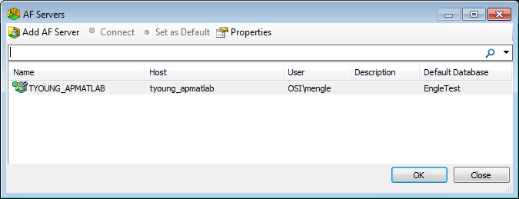

The general startup window will look like this:

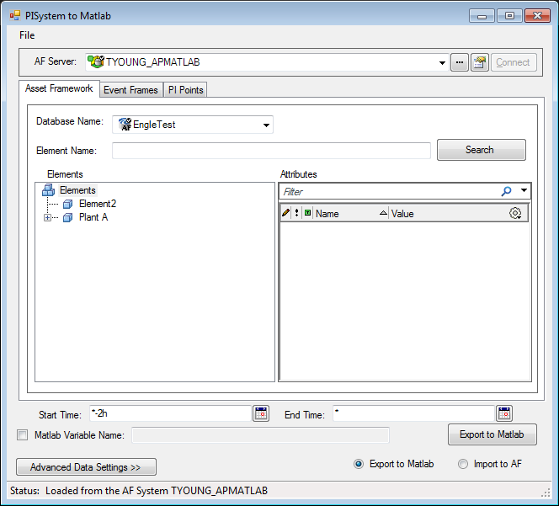

The AF Database being used can be easily changed with the Database Picker and will automatically update the AFTreeView.

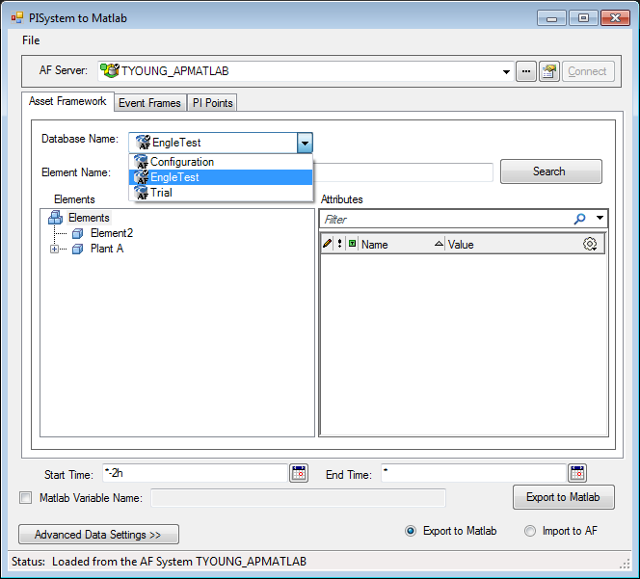

Selecting any Element from the AFTreeView updates the AF Control View with that Element’s available Attributes. The values of each of those attributes are loaded in and updated. If there is no reference or they do not load there is an error in the connection somewhere.

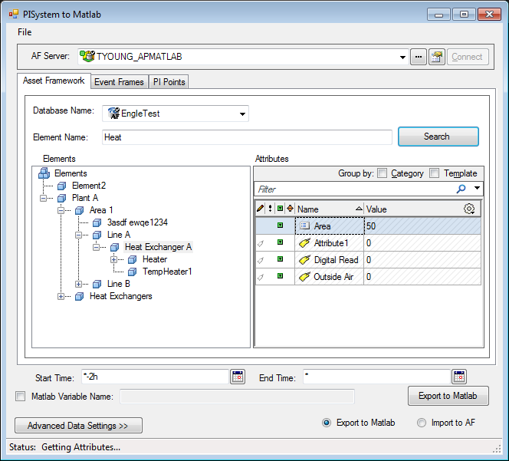

For Constant Attributes, like Area in the Figure above, a time range isn’t necessary. However, for the PI Tags, a Start and End Time can be set for the data collection.



The Calendar button opens the AF Date Time Picker familiar to users to select dates. The times selected can also be in Date format or Absolute Time. The User-input is checked when creating the AF Time Range.

Before Exporting to Matlab, the variable name of the data in the Matlab Workspace can be set. If none is set or the name is empty, the attribute name is used. The user-input and the attribute name are made into a Matlab compatible name and checked as to not overwrite any variable in the Matlab space or previously named exported data.

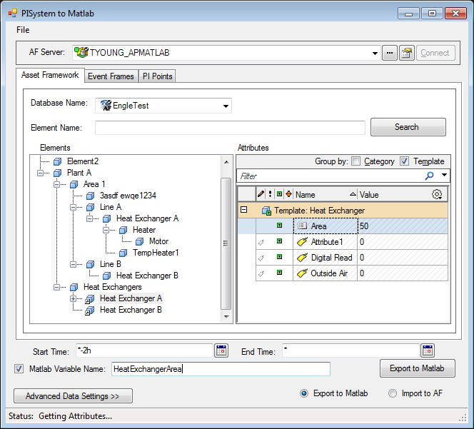

Clicking the ‘Export to Matlab’ Button brings the data and the time stamp to Matlab for use.

## ADVANCED DATA SETTINGS

When Exporting Data there are a couple options for the PI Tags. The Timestamps can be disabled, but the default is that a timestamp is exported with each data value. Otherwise the data can come in three formats, the raw data, sampling at evenly spaced intervals, or profiled sampling. The profiled sampling includes the samples at evenly spaced intervals and the maximum, minimum, and an exceptional value for the profiled interval. The default is raw data.

To set these Data Preferences the Advanced Data Settings provides a dialog. Intervals are only important to the Sampling and Profiled Sampling formats. Closing the form or pressing ok, inputs the changes selected, so that the next export follows these settings.

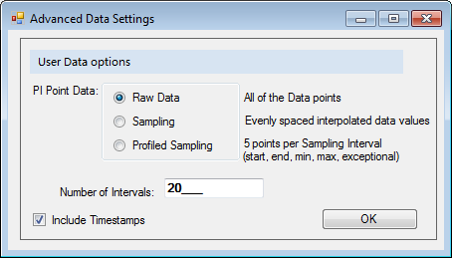

**Note:** To read a timestamp in Matlab, execute the code:

datestr(timestamp, ‘dd-mmm-yyyy HH:MM:SS.FFF’);

Example Result: 29-Jan-2015 15:08:11.228

# THE ASSET FRAMEWORK TAB

## THE ELEMENT TREEVIEW

The Elements are arranged in an AFTreeView and after setting the AFRoot only Elements is visible. For quick searching, entering in the AFElement name or part of the name into the available textbox and searching will navigate to the Element expanding along the path. If there are multiple Elements that fit the criteria pressing search again with the same search query will iterate through the qualified Elements.

The AF Tree View also has an AFMenu. Right clicking over the Elements Node provides a way to Refresh and choose how the Elements are arranged. Right clicking over the other nodes allows the user to Refresh the tree, make the clicked node the new Root (helpful for large AF Systems), and Find Children Elements or Event Frames.

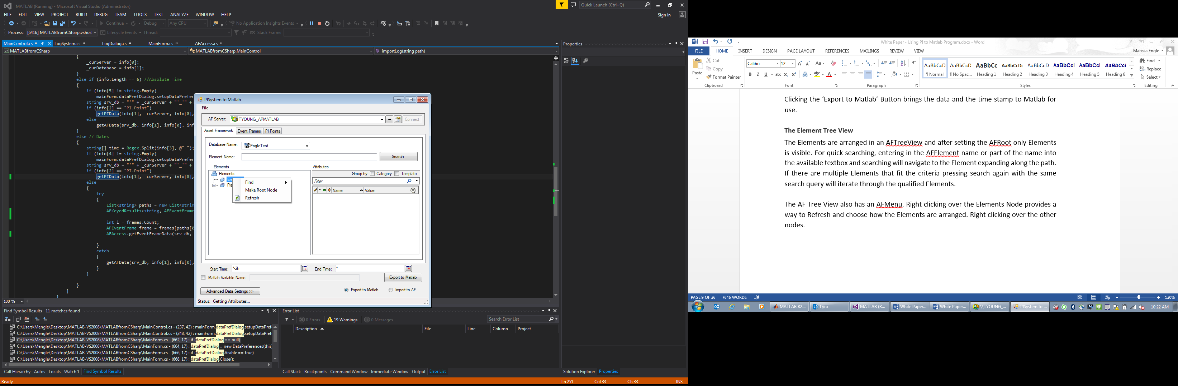 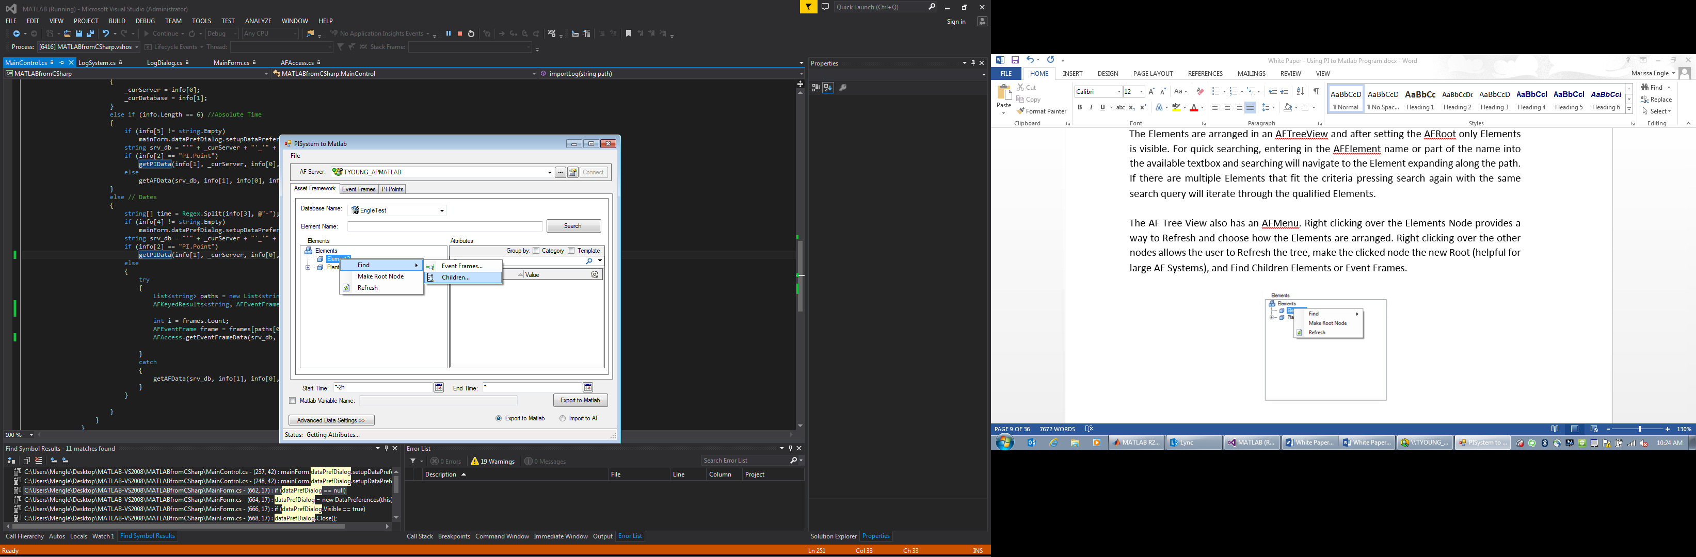

To Find Children an Element Search is opened. If only one element is chosen, that element is expanded to in the AFTreeView and selected. If multiple are selected, similar to the Search, selecting the search button will iterate through the Elements.

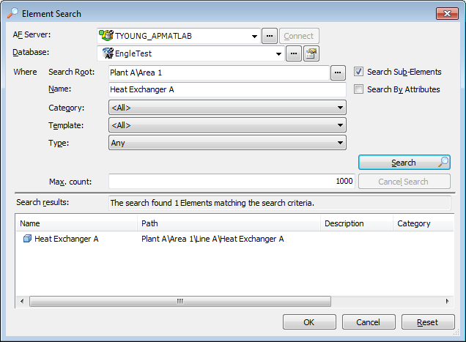

To Find Event Frames, an Event Frame Search Criteria dialog appears. Even without searching, if the user presses ok, the results from the previous search or inputted criteria will load onto the Event Frames Page. If a search is done, all found Event Frames will be loaded. If the user selects Event Frames in the Search Results, only those selected are loaded.

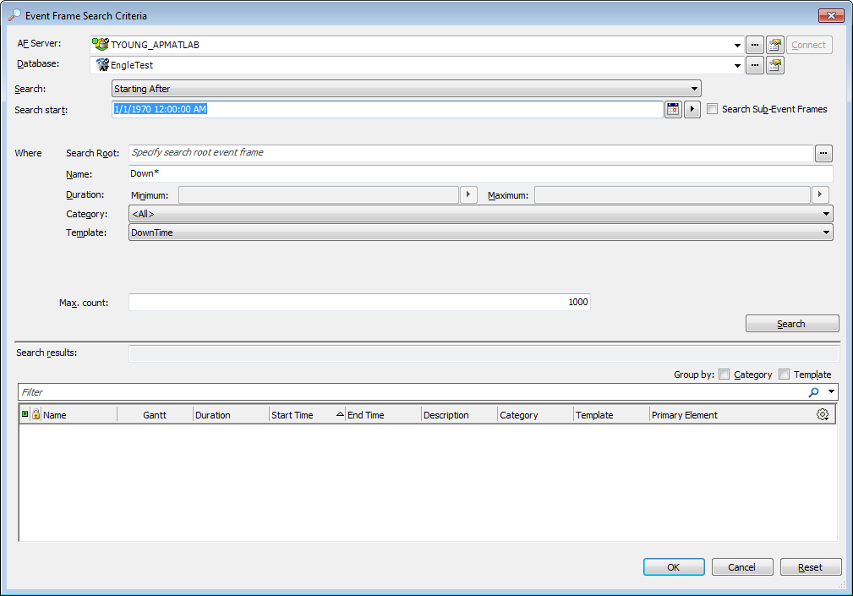

## TRANSFERRING DATA: EXPORT AND IMPORT

There is the ability to switch from Exporting to Matlab to Importing to AF Tree View. This is only available on the Asset Framework Tab Page. Using the Radio Buttons, the user can switch between the two actions. However this is only available to those with Admin Access to the Servers to avoid non – administrator users from overwriting data.

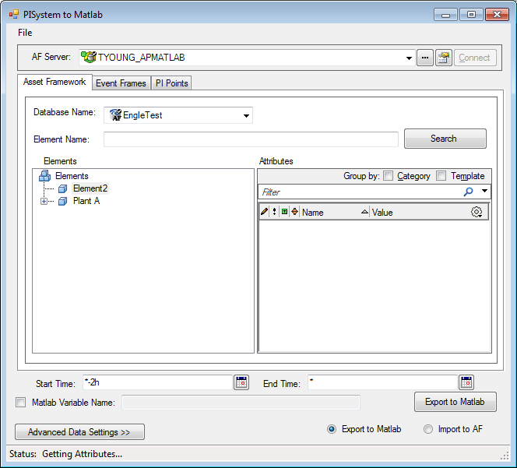 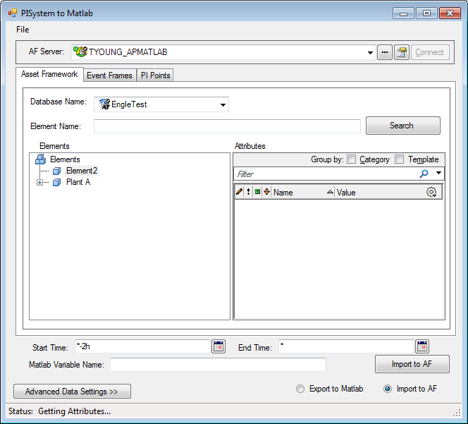

To Import to a selected attribute, the name of the Matlab variable in the Matlab workspace must be provided. After clicking Import, the user can see the change in the Attribute value on the screen and in PI System Explorer. If writing to something that is Read-Only, there will be a message that states that the Attribute cannot be written to and no change will be made.

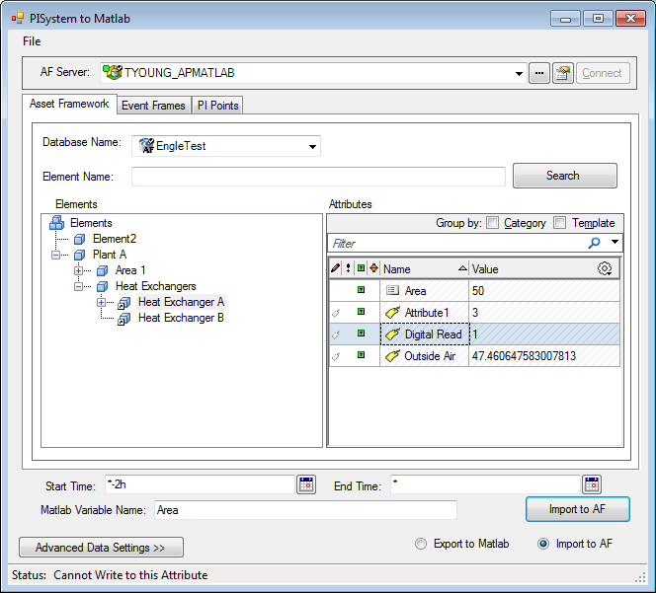

# THE EVENT FRAMES TAB

If no previous Event Frame Search has been executed, there will be no data loaded onto this page. Otherwise the user can select an Event Frame and an Attribute and Export the data to Matlab.

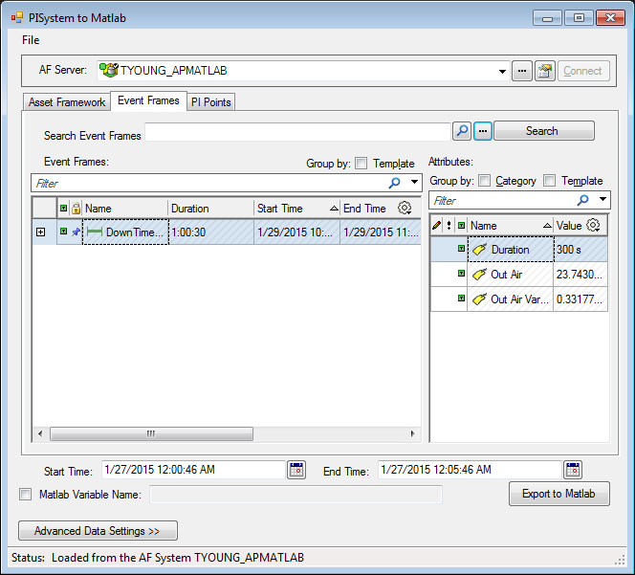

## SEARCH FOR AN EVENT FRAME

To search for Event Frames from this page there are multiple options.

1. Search for the Event Frame Name in the textbox and press Search. If there is no text it will bring up all of the Event Frames.
2. If a single Event Frame is needed, click the 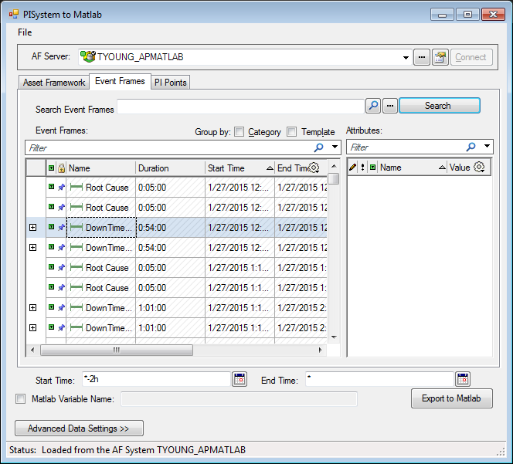. The Event Frame Search dialog allows for a more detailed search. If the Event Frame is already loaded it is selected.
3. For multiple Event Frames, the  button, opens the Event Frame Criteria Search used by the AF Tree View.

The Search Results can be further filtered and grouped by Category and Template.

## EVENT FRAME TIME RANGE

When an Event Frame is selected, the Date Time Picker is set to those times. Navigating back to the Asset Framework, the times remain the same and more data during the Event Frame can be exported.

# THE PI POINTS TAB

These PI Points are loaded when the AF Server connects to the PI Server. Multiple PI Points can be exported at a time. If a name is provided the name is used for only the first PI Point. The others use the name of the PI Point.

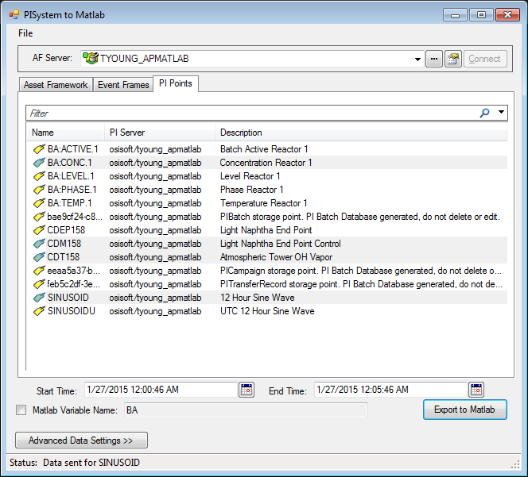

# SAVING YOUR WORK

## THE TRANSACTION HISTORY

For each export executed by the program, there is a log of the transaction saved. Using the File Menu and selecting View Log… the user can look at the current transaction log.

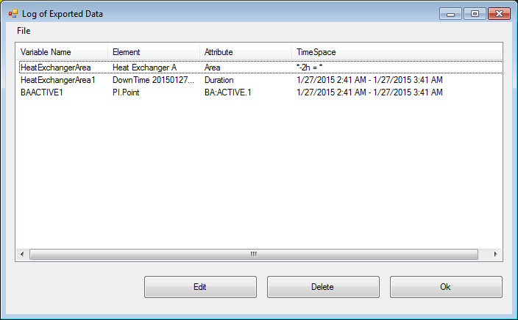

Each transaction log can be deleted or edited for a different variable name or time range.

## EDITING A TRANSACTION

To Edit a Transaction, either select the item and click Edit or double click the item. An Editing Dialog will open to allow for changes in the data.

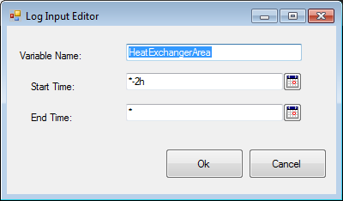

After making an Edit, the previous data variable will be deleted from the Matlab Workspace and replaced with the new data.

## SAVING THE TRANSACTION LOG

The Transaction Log can be saved from both the Main Window and the Log Window. Clicking File and then Save … opens a save file window to pick the location and name of the text file. The user will also be asked if they want to save their work prior to exiting the Program.

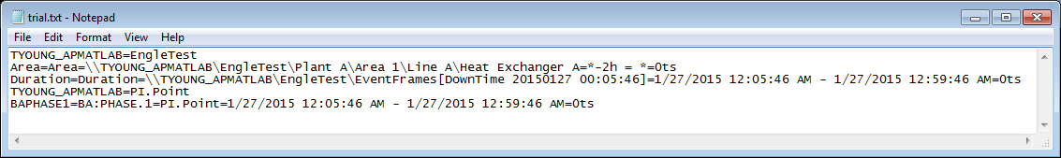

## IMPORTING THE TRANSACTION LOG

The text file can also be used to make the same exports again when reopening the program. Clicking File and then Import File… opens a file search window to find the text file. The data will be exported into the Matlab Workspace with the same variable names as before, unless the variable already exists it will iterate the name.

# THE MATLAB WINDOW

Matlab will not close with the program. You can reopen and reconnect with the same Matlab, if you accidently closed the window, however the Transaction log will not hold the old exports.

If by accident the Matlab window was closed. The program will ask the user, after failing to export data, if they would like to reopen Matlab with the same exports as in the log. The Matlab file will be reopened and a temporary text file will be saved and imported in.

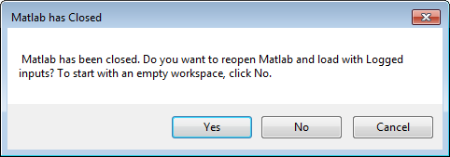

If the user doesn’t want Matlab open, the exports will still be logged without actual transferring data.

# REVISION HISTORY

|  |  |
| --- | --- |
| 30-Jan-15 | Initial version by Marissa Engle |